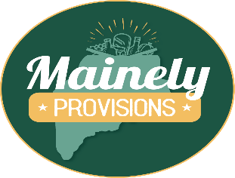
Dear New Employee,
Welcome to the Mainely Provisions team! You're now a part of our mission to offer the local community a unique grocery shopping experience that emphasizes friendly, personalized service. Our store prides itself on a wide selection of fresh produce, premium meats, organic foods, delicious bakery items, and a diverse range of craft beers, wines, and spirits, all under the scenic backdrop of Sugarloaf Mountain. We aim to be more than just a grocery store by providing health-conscious and locally grown products for a balanced diet.
Joining Mainely Provisions means becoming part of a supportive family that values the contributions of each team member and strives to create a sense of community and belonging. We're excited to have you with us and look forward to the positive impact you'll make. Please feel free to reach out for any support or questions as you start your journey. Welcome aboard, and we're eager to witness the wonderful additions you'll bring to our team and the broader Kingfield community.
Warm regards, and welcome to the team!
Joe Christpher & Ryan Rother

English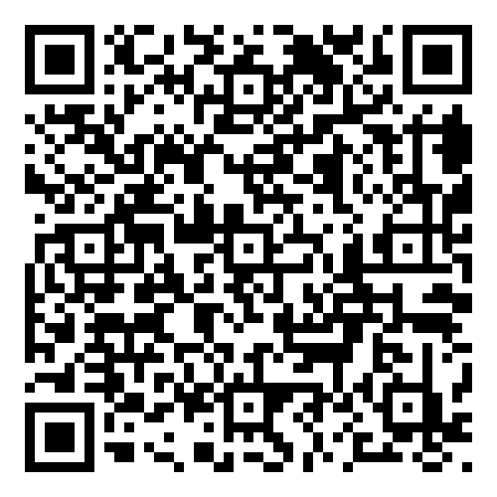 Espanol
Handbook - Your Employee Handbook can be found by scanning the QR code below. You are required to read the handbook once you are hired – by working here you are agreeing to follow these polices so please familiarize yourself with them. It is updated periodically, and it is your responsibility to keep yourself informed on those updates. Always feel free to reach out to your manager or HR with questions.

At-Will Employment - Your employment with Mainely Provisions is on an "at-will" basis. This means your employment may be terminated at any time, with or without notice and with or without cause. Likewise, we respect your right to leave the Company at any time, with or without notice and with or without cause.

Pay Stubs - You can access your pay stubs, W-2, and change your personal information through your Paychex account. You will be required to set that up once you have completed the onboarding process.

Work Week - Our pay period goes from Monday - Sunday. Paychecks are deposited every Thursday.

Schedule – All work schedules will be posted in designated areas or online, based on your department on every Friday for the following week. If, by Saturday afternoon, if you are uncertain of your work schedule for the following week, please contact your supervisor. *All Schedule requests must be submitted by Monday for the next week.
Parking - All employees are required to park in designated parking areas.

Attendance - All employees must arrive punctually, dressed, and prepared to work daily. Notify your manager beforehand if you anticipate being late or absent and provide applicable documentation if needed. Leaving work during the day requires supervisor approval, and repeated tardiness or absenteeism may lead to disciplinary measures, potentially including termination. Employees may be required to come in early, work late, or work overtime from time to time, depending on various factors such as workloads, seasonal peaks and staffing needs.

Clocking in and Out - employees are required to clock in and out for every shift. This is part of your job. Failure to do so will result in disciplinary action. If you show up early, do not clock in until you are scheduled to work. Having a friend clock you in is not allowed. You must clock out if you are leaving the building while on a break

Time Off - Mainely Provisions provides paid time off to eligible employees in accordance with Maine’s Earned Paid Leave (EPL) law. All time off must be approved in advance by your manager. EPL is never paid out—neither during employment nor upon separation.
Holidays - There are 7 recognized holidays per calendar year. New Years Day, Memorial Day, Easter, Thanksgiving, Christmas, Independence Day and Labor Day. In order to qualify for the holiday rate or pay, you must have worked a minimum of 20 hours weekly for 12 consecutive weeks prior to the week in which the holiday resides. You must also work your scheduled shift immediately preceding and following the holiday.
- Holiday Pay - Easter, Thanksgiving, and Christmas day the grocery store will be closed. (The convenience store is open on Easter.) All qualifying employees will receive compensation equal to an average shift's wages based on the previous 12 weeks' schedules.
- Holiday Rate - All qualified employees who work on New Year's Day, Memorial Day, Independence Day, and Labor Day will receive 1.5 times their customary rate of pay for their shift (including employees that work at the convenience store on Easter. )

Benefit Guide - If you have been hired as a year-round full-time employee you will be eligible to sign up for benefits after 60 days of employment. Please ask your manager for one. After 9 months of employment, you will be eligible to sign up for our 401K account with a 3% match.

Dress code - How you look affects Mainely Provisions' image and we pride ourselves on being leaders in the community and industry. Follow community hygiene standards: wear clean clothes, groom well, and wear suitable work clothes. All employees must be wearing authorized company logo items. Failure to do so may result in being sent home to change. Pants or jeans must be clean, presentable, and fit properly at your waist. Closed-toe shoes are required (no slippers) and hair ties, hair nets, or hats are required when working in food service. Name tags are provided, and we encourage everyone to wear one. Earbuds are not allowed while working on the floor.

Cell phones - While Mainely Provisions allows employees to have personal cell phones at work these devices should remain off during work hours to ensure productivity and safety. Use personal devices only during breaks or emergencies, maintaining consideration for others. Earbuds are not allowed while working.

Employee Discounts - Employees receive a 5% discount on food.

General Safety - All Mainely Provisions employees must prioritize a safe workplace, promptly reporting any hazards and adhering to Company safety regulations. Failure to comply may lead to disciplinary measures, potentially termination. Report any work-related illnesses or injuries to your manager within 24 hours, completing the necessary forms.

Workplace privacy - Company property, including but not limited to lockers, phones, computers, tablets, workplace areas, remains under the control of the Company and is subject to inspection at any time, without notice to any employee and without their presence. We assume no responsibility for the loss of, or damage to, your property maintained on Company premises including that kept in lockers and desks.

Harassment & Discrimination - Harassment and discrimination are illegal and not tolerated at all at Mainely Provisions. Non-compliance will result in disciplinary action.

Standards of Conduct & Code of Ethics - Mainely Provisions aims for a positive work environment. Working here entails agreeing to follow rules and sharing the responsibility of enhancing our work environment. We expect and insist on having a professional work environment. Non-compliance will result in disciplinary action.

Drugs & Alcohol - Mainely Provisions is committed to provide a safe, healthy, and productive work environment. Being under the influence of alcohol, illegal drugs (as classified under federal, state, or local laws), or other impairing substances while on the job may pose a serious health and safety risk to others and will not be tolerated.

Diversity, Equity and Inclusion - Our company is dedicated to cultivating a culture of diversity, equity, and inclusion, recognizing that our human capital is our most valuable asset. All employees are expected to uphold these values, promoting dignity and respect. Inappropriate conduct may result in disciplinary action.

Conflict resolution - Mainely Provisions aims for a comfortable, productive, legal, and ethical work environment. We acknowledge that workplace issues may arise and encourage open communication to discover and resolve them. Please bring any problems, concerns, or grievances to the attention of the owners for effective conflict resolution through our established procedure.

Disciplinary / Corrective Process - Violating Mainely Provisions' policies can lead to corrective and disciplinary measures such as demotion, transfer, leave without pay, or termination. While there's a preference for a progressive discipline approach, the company retains the right to terminate or discipline employees immediately for misconduct or inadequate work quality. The disciplinary process might involve coaching briefs, corrective action, verbal and written warnings, potentially leading to demotion, transfer, leave, or termination.

Introductory period- The first 60 days of your employment is considered an introductory period. During this period, you will become familiar with Mainely Provisions and your job responsibilities, and we will have the opportunity to monitor the quality and value of your performance and make any necessary adjustments in your job description or responsibilities. Completion of this introductory period does not imply guaranteed or continued employment.

Training - In most cases, and for most departments, training is done on an individual basis by the department manager. Even if you have previous experience in the specified functions of your job duties, you must learn our specific procedures and the responsibilities of the specific position. If you ever feel you require additional training, consult your manager.

As a new employee, you will attend an “Essentials” training within 6 months of employment. Your manager or Ryan will schedule that for you.

Contacts:
- Rachel Stymiest (GM) 207-213-3317
- Lisa Brooks (C Store Manager) 207-672-6724
- Ryan Rother (managing partner) 207-747-7930
- Joe Christopher (owner) 207-831-7373
- Human Resources 207-387-9680 HR@upmgt.org

